**ASSIGNMENT 3**

**1 What Does Build Mean?**

*The term build may refer to the process by which source code is converted into a stand-alone form that can be run on a computer or to the form itself. One of the most important steps of a software build is the compilation process, where source code files are converted into executable code. The process of building software is usually managed by a build tool. Builds are created when a certain point in development has been reached or the code has been deemed ready for implementation, either for testing or outright release.

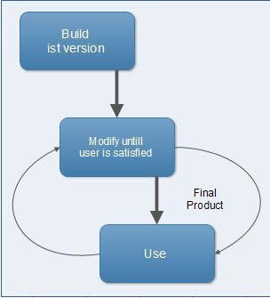

# 2 What is Project?

A project is a group of tasks that need to complete to reach a clear result. A project also defines as a set of inputs and outputs which are required to achieve a goal. Projects can vary from simple to difficult and can be operated by one person or a hundred.

# 3 What is a Version?

Software versioning is a way of numbering different releases of a particular software program as it is developed and released, all of which have the same general function, but each latest version comes with some improvement, upgraded or customized. Generally, it is a process to categorize the unique states of computer software for both internal use and release designation. Usually, the version identifier is a number, a word, or both. For instance, the initial release of a program is commonly denoted by version 1.0. The term version mainly applies to Web services, software, and operating systems.

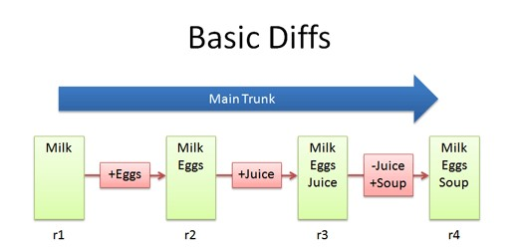

## **4 What is software deployment?**

Software deployment includes all of the steps, processes, and activities that are required to make a software system or update available to its intended users. Today, most IT organizations and software developers deploy software updates, patches and new applications with a combination of manual and automated processes. Some of the most common activities of software deployment include software release, installation, testing, deployment, and performance monitoring.

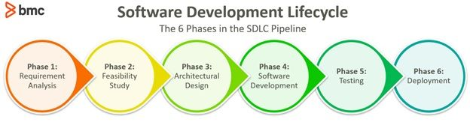

## 5 What is a beta version?

The beta version, a pre-release build of software that may contain bugs or performance issues, is released after the alpha phase in the software release life cycle. While [alpha testing](https://www.centercode.com/glossary/alpha-testing" \t "https://www.centercode.com/blog/_blank) is typically conducted internally, beta testing is focused on testing the software with a group of end users. The distinctions between [alpha and beta versions](https://www.centercode.com/blog/alpha-vs-beta-testing" \t "https://www.centercode.com/blog/_blank) lie in the testing audience, the objectives of testing, and the timeline of each stage.



# 6 Refactoring

Refactoring is improving or updating code without changing its external function or nonfunctional attributes. Refactoring cleans up the nonfunctional elements of software, making it easier to maintain, extend, integrate, align with evolving standards, and continue performing at acceptable speeds. It changes nothing about core functionality from the user’s perspective other than occasional cosmetic changes and improved overall performance.

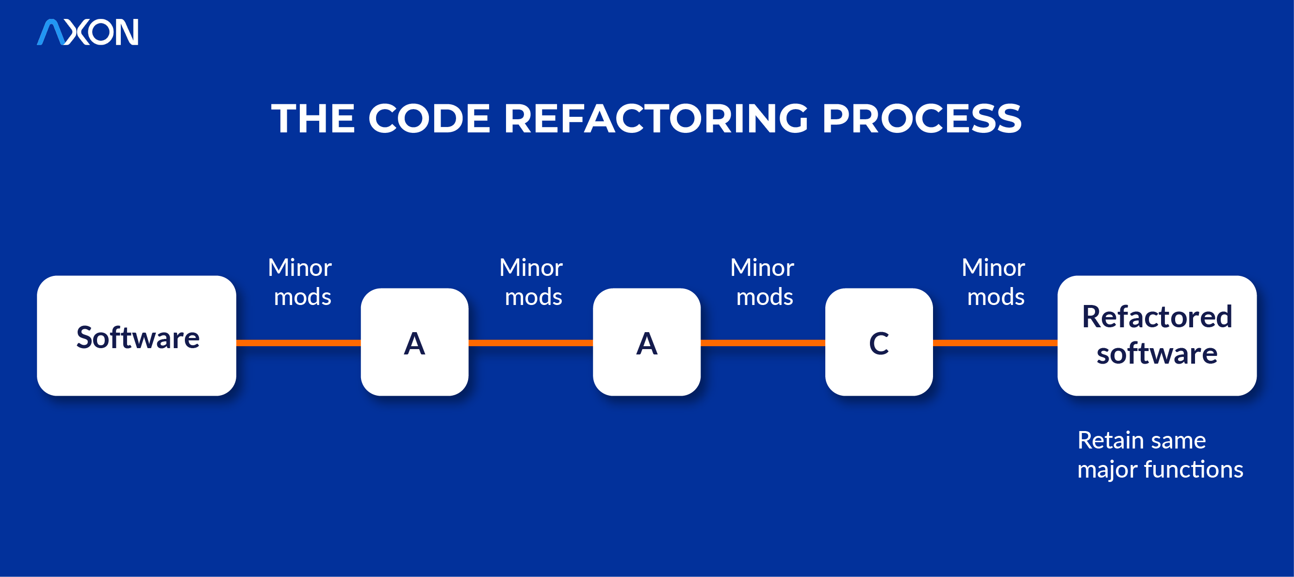

## 7 ****What is a Software Walkthrough?****

**Software walkthrough is a type of [peer review](https://testsigma.com/blog/peer-review-in-software-testing/" \t "https://testsigma.com/blog/software-walkthrough/_blank) where a designer or programmer guides members of the development team and other stakeholders through a software product. During this process, participants ask questions and comment on potential errors, deviations from development standards, and other issues.**

**Also, participants typically go through the various features and functionalities of the software step by step, discussing and analyzing its behavior, design, and functionality. It can include examining the user interface, testing specific**

**functionalities, and reviewing the underlying code or architecture.**

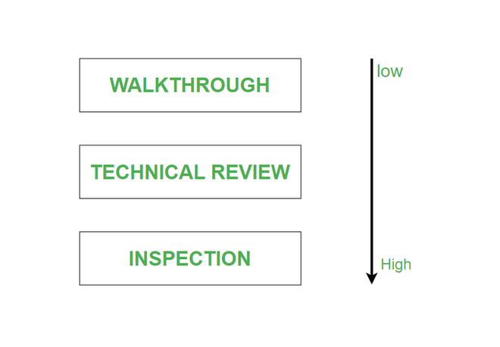

## **8 What Is BRS Document?**

BRS stands for a business requirement specification which is aimed to show how to meet the business requirements on a broader level. A BRS document is one of the most widely accepted specification documents. It’s quite essential, and a BRS is usually created at the very beginning of the product’s life cycle and describes the core product goals or needs client is willing to achieve with certain software or product. This one is usually created by a business analyst based on other stakeholders specifications and after a thorough analysis of the client company. Usually, the final version of the document is reviewed by the client to make sure that all business stakeholders’ expectations are correct.

## 9 What is(LLD)?

LLD, or Low-Level Design, is a phase in the software development process where detailed system components and their interactions are specified. It involves converting the high-level design into a more detailed blueprint, addressing specific algorithms, data structures, and interfaces. LLD serves as a guide for developers during coding, ensuring the accurate and efficient implementation of the system’s functionality. LLD describes class diagrams with the help of methods and relations between classes and program specs.

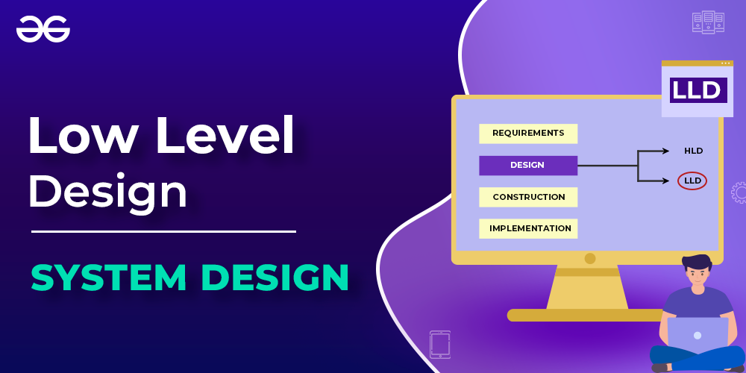

# 10 RAD (Rapid Application Development) Model

RAD is a linear sequential software development process model that emphasizes a concise development cycle using an element based construction approach. If the requirements are well understood and described, and the project scope is a constraint, the RAD process enables a development team to create a fully functional system within a concise time period.RAD (Rapid Application Development) is a concept that products can be developed faster and of higher quality through

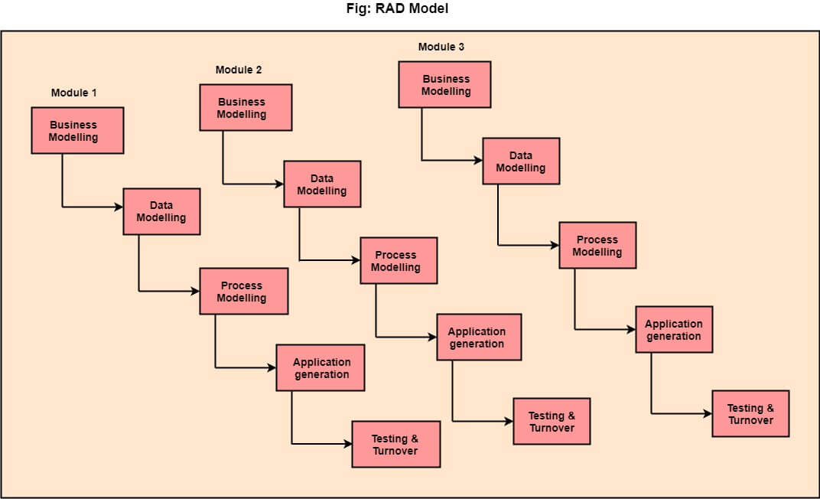

# 11 Prototype Model

The prototype model requires that before carrying out the development of actual software, a working prototype of the system should be built. A prototype is a toy implementation of the system. A prototype usually turns out to be a very crude version of the actual system, possible exhibiting limited functional capabilities, low reliability, and inefficient performance as compared to actual software. In many instances, the client only has a general view of what is expected from the software product. In such a scenario where there is an absence of detailed information regarding the input to the system, the processing needs, and the output requirement, the prototyping model may be employed.

